Project Design Phase-II
Technology Stack (Architecture & Stack)

Date | 14 July 2026
Team ID
Project Name | HouseHunt - House Rent Application
Maximum Marks | 4 Marks

Technical Architecture
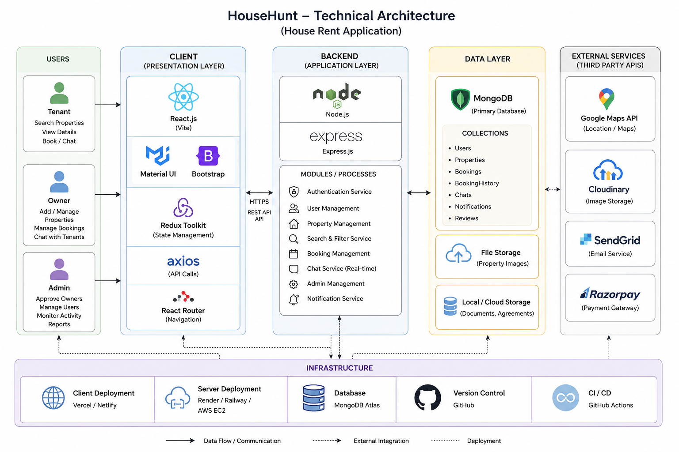
React (Vite) UI -> Axios -> Express.js REST API -> Controllers -> Mongoose Models -> MongoDB Atlas
Admin, Owner and Tenant access the system through the React frontend. Owners manage properties, tenants search and book, and admins approve owners.

Table 1: Components & Technologies
S.No | Component | Description | Technology
1 | User Interface | Responsive web application | React.js, Bootstrap, Material UI, HTML, CSS, JavaScript
2 | Application Logic-1 | Authentication & Authorization | Node.js, Express.js, JWT, bcrypt
3 | Application Logic-2 | Property Management | Express.js REST APIs, Mongoose
4 | Application Logic-3 | Booking & Chat | Express.js, Axios
5 | Database | Application data | MongoDB
6 | Cloud Database | Managed database | MongoDB Atlas
7 | File Storage | Property images | Local/Cloudinary
8 | External API-1 | Maps/Location | Google Maps API (optional)
9 | External API-2 | Email Notifications | Nodemailer SMTP
10 | Machine Learning | Not Applicable | N/A
11 | Infrastructure | Deployment | Vercel (Frontend), Render/Node Server, MongoDB Atlas

Table 2: Application Characteristics
S.No | Characteristic | Description | Technology
1 | Open Source Frameworks | Frontend and backend frameworks | React, Express, Node.js, Mongoose
2 | Security | Authentication and encryption | JWT, bcrypt, CORS, Helmet
3 | Scalable Architecture | MVC based REST architecture | React + Express + MongoDB
4 | Availability | Cloud hosted services | Render, Vercel, MongoDB Atlas
5 | Performance | Fast UI and optimized APIs | Axios, MongoDB Indexing

